**SOLAR BASED AUTOMATIC LIGHT**

**CONTROL SYSTEM(ON/OFF)**

*in*

**Electrical and Electronics Engineering**

*Submitted by*

**Arpita Sukhwal (21EEE1004)**

**C Vinay Kumar Reddy (21EEE1007)**

**Eshani Naik (21EEE1010)**

*Under the supervision of*

# Dr. Mallikarjun

# Assistant Professor

# National Institute of Technology Goa - Wikipedia

Department of Electrical and Electronics Engineering

National Institute of Technology Goa

May 01, 2024

**ABSTRACT**

Solar based Automatic Light Control System is a simple yet powerful concept, which uses transistor as a switch. By using this system manual works are 100% removed. It automatically switches ON lights when the sunlight goes below the visible region of our eyes. This is done by a sensor called Light Dependant Resistor (LDR) which senses the light actually like our eyes. It automatically switches OFF lights whenever the sunlight comes, visible to our eyes. By using this system energy consumption is also reduced because nowadays the manually operated lights are not switched off even the sunlight comes and also switched on earlier before sunset. In this project, no need of manual operation like ON time and OFF time setting. This project clearly demonstrates the working of transistor in saturation region and cut-off region. It is very much useful in the remote locations. As it is based on the solar energy, does not require any electrical transmission lines.

**TABLE OF CONTENTS**

1.Abstract

2.Introduction

3.Hardware description

-Components description

4.Block diagram

5.Circuit diagram

6.Working principle

7.Testing

8.Advantages

9.Applications

10.Conclusion

**INTRODUCTION**

Solar based automatic lighting system is designed to automatically switch ON the light alongside the roads or in the remote areas where electrical transmission lines are not available or the light lamp just outside our house on the onset of dark weather or switch them off automatically after sunrise or during the light hours. We need to save or conserve energy because most of the energy sources we depend on, like coal and natural gas can't be replaced. Once we use them up, they're gone forever.

Saving power is very important, instead of using the power in unnecessary times it should be switched off. In any city “STREET LIGHT” is one of the major power consuming factors. Most of the time we see street lights are controller has an LDR which is used to detect the ambient light. If the ambient light is below a specific value the lights are turned ON. A light dependent sensor is used to track the sun light and when the sensors goes dark the led will be made on and when the sensor founds light the led will be made OFF. It clearly demonstrates the working of transistor in saturation region and cut-off region.

Solar based automatic Light Control System is a simple yet powerful concept, which uses transistor as a switch. By using this system manual works are 100% removed. It automatically switches ON lights when the sunlight goes below the visible region of our eyes.

This is done by a sensor called Light Dependent Resistor (LDR) which senses the light actually like our eyes. It automatically switches OFF lights whenever the sunlight

comes, visible to our eyes. This project exploits the working of a transistor in saturation region and cut-off region to switch ON and switch OFF the lights at appropriate time with the help of an electromagnetically operated switch.

A street light, lamppost, street lamp, light standard, or lamp standard is a raised source of light on the edge of a road or walkway, which is turned on or lit at a certain time every night. Modern lamps may also have light-sensitive photocells to turn

them on at dusk, off at dawn, or activate automatically in dark weather.

**HARDWARE DESCRIPTION**

**List of Components**

1. Transistor (BC 547-NPN)
2. LDR (Light Dependence Resistor)
3. Resistors
4. LED (Light Emitting Diode)
5. PCB (Printed Circuit Board)
6. Battery
7. Solar panel

**Components Description**

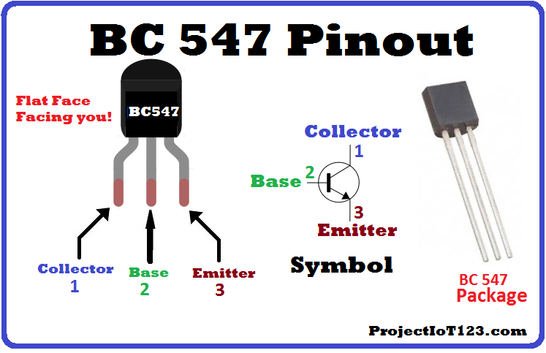***Transistor (BC 547-NPN)***

It is a BJT transistor and is often used to satisfy the need of quick switching. The transistor is operated in the Saturation and Cutoff Region when we will use it as a Switch. This transistor biasing current should maximum of 5mA. If we apply more than 5mA will damage the Transistor. Therefore always we need to connect a resistor in series with base pin. This resistor value (**RB**) can be calculated using the below formulae.

**RB= VBE / IB**

When the switch is in open condition, so the voltage does not apply to the base terminal. Now the transistor is in Reverse Bias states, so the current does not flow through the collector & emitter.

***LDR (light dependence resistor)***

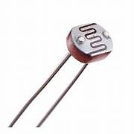An LDR or [light dependent resistor is also known as photo resistor](http://en.wikipedia.org/wiki/Photoresistor), photocell, photoconductor. It is a one type of resistor whose resistance varies depending on the amount of light falling on its surface. When the light falls on the resistor, then the resistance changes. These resistors are often

used in many circuits where it is required to sense the presence of light. These resistors have a variety of functions and resistance. For instance, when the LDR is in darkness, then it can be used to turn ON a light or to turn OFF a light when it is in the light.

***Solar panel***

A solar panel is a device that converts [sunlight](https://en.wikipedia.org/wiki/Sunlight) into [electricity](https://en.wikipedia.org/wiki/Electricity) by using [photovoltaic](https://en.wikipedia.org/wiki/Photovoltaic) (PV) cells. PV cells are made of materials that produce excited [electrons](https://en.wikipedia.org/wiki/Electrons) when exposed to light. The electrons flow through a circuit and produce [direct current](https://en.wikipedia.org/wiki/Direct_current) (DC) electricity, which can be used to power various devices or be stored in [batteries](https://en.wikipedia.org/wiki/Battery_(electricity)). Solar panels are also known as solar cell panels, solar electric panels, or PV modules.

***Resistor***

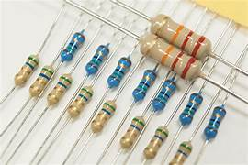A resistor is a [passive](https://en.wikipedia.org/wiki/Passivity_(engineering)) [two-terminal](https://en.wikipedia.org/wiki/Terminal_(electronics)) [electrical component](https://en.wikipedia.org/wiki/Electronic_component) that implements [electrical resistance](https://en.wikipedia.org/wiki/Electrical_resistance) as a circuit element. In electronic circuits, resistors are used to reduce current flow, adjust signal levels, to [divide voltages](https://en.wikipedia.org/wiki/Voltage_divider), [bias](https://en.wikipedia.org/wiki/Biasing) active elements, and terminate [transmission lines](https://en.wikipedia.org/wiki/Transmission_line), among other uses.

***LED (light emitting diode)***

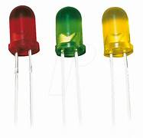A light-emitting diode (LED) is a [semiconductor](https://en.wikipedia.org/wiki/Semiconductor) [device](https://en.wikipedia.org/wiki/Electronics) that [emits light](https://en.wikipedia.org/wiki/Light#Light_sources) when [current](https://en.wikipedia.org/wiki/Electric_current) flows through it. [Electrons](https://en.wikipedia.org/wiki/Electron) in the semiconductor recombine with [electron holes](https://en.wikipedia.org/wiki/Electron_hole), releasing energy in the form of [photons](https://en.wikipedia.org/wiki/Photon). The color of the light (corresponding to the energy of the photons) is determined by the energy required for electrons to cross the [band gap](https://en.wikipedia.org/wiki/Band_gap) of the semiconductor.[[5]](https://en.wikipedia.org/wiki/Light-emitting_diode#cite_note-5) White light is obtained by using multiple semiconductors or a layer of light-emitting [phosphor](https://en.wikipedia.org/wiki/Phosphor) on the semiconductor device.

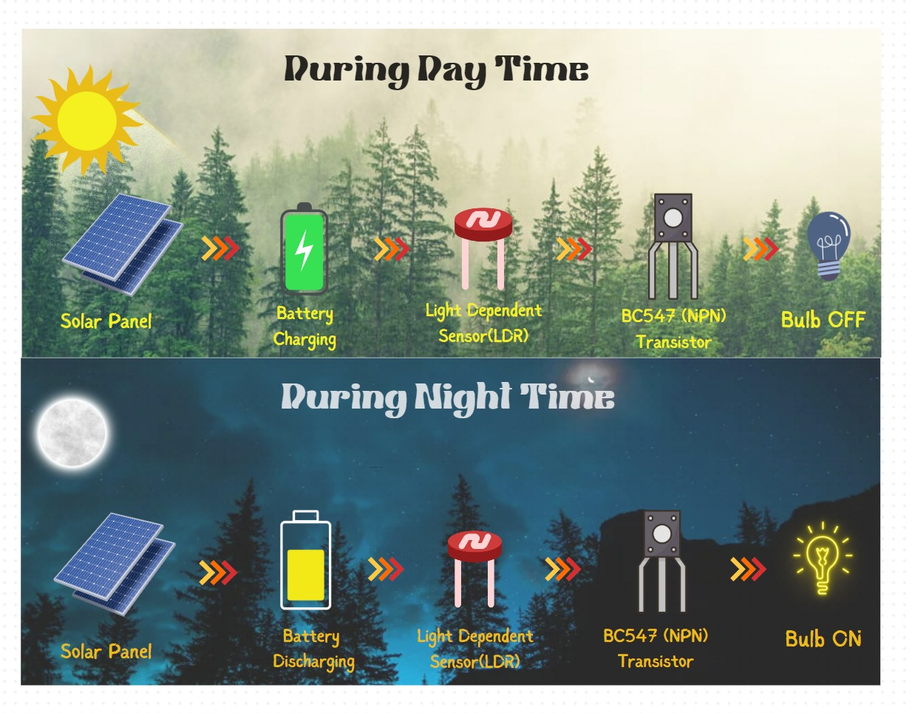**BLOCK DIAGRAM**

**CIRCUIT DIAGRAM**

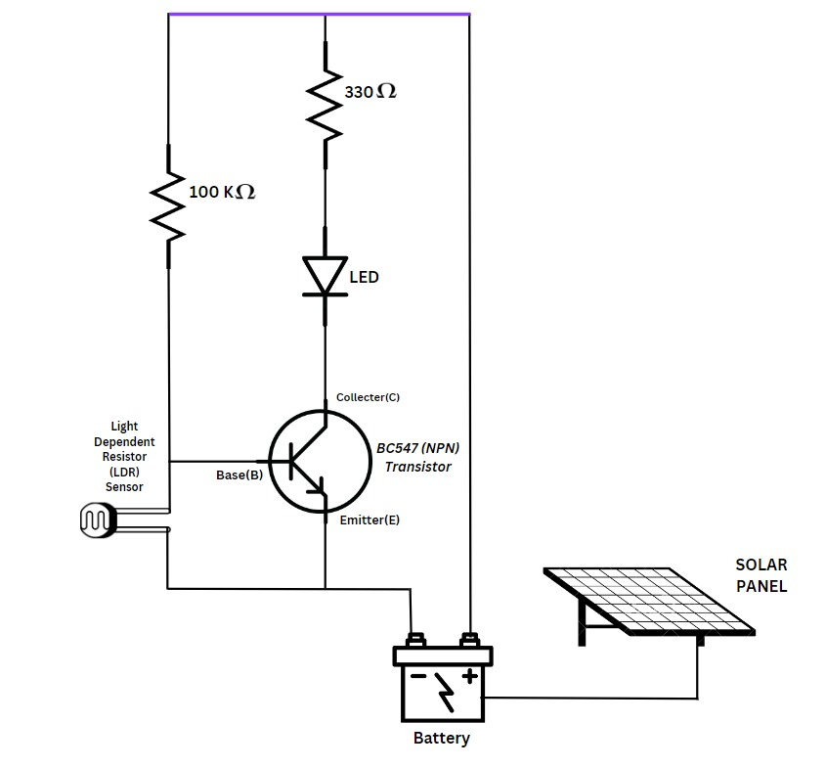

**WORKING PRINCIPLE**

The main part of this circuit is the light dependent resistor (LDR). It is a sensor which is a particular kind of resistor whose resistance decreases when exposed to light. Likewise it offers high resistance in dark. The resistance value changes from few 100 ohms to mega ohm range. The LDR is placed in a potential divider network. So voltage across LDR changes with intensity of light.

LDR offers Very high Resistance in darkness. In this case the voltage drop across the LDR is more than 0.7V. This voltage is more sufficient to drive the transistor into saturation region. In saturation region, IC (Collector current) is very high. Because of this IC. The relay gets energized, and switches on the light.

LDR offers Very low Resistance in brightness. In this case the voltage drop across the LDR is less than 0.7V. This voltage is not sufficient to drive the transistor into saturation region. Then the IC (Collector current) is very low. Because of the low IC of the transistor, the transistor acts of switch OFF then the light will be switched off.

The whole system runs with the solar energy. When the brightness is there, the battery will gets charged through the solar panel and at this time the light is in OFF stage. When it is dark, the solar panel doesn’t get any energy from the sun and the battery do not charge. now the battery moves into the discharge mode to switch ON the light.

**TESTING**

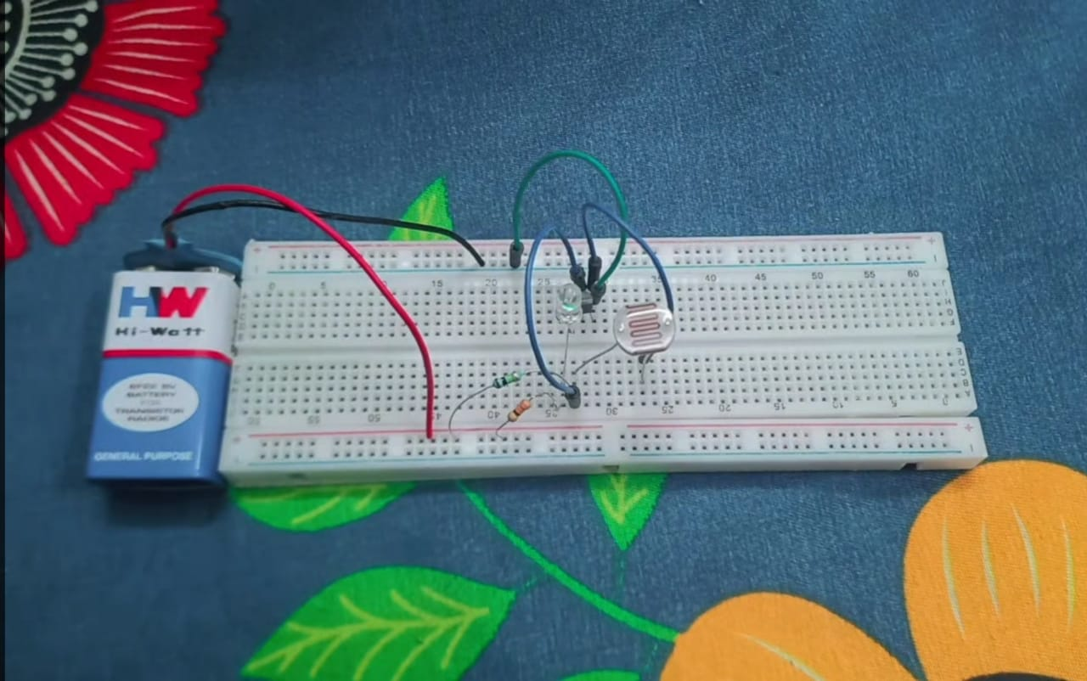 ***During day time***

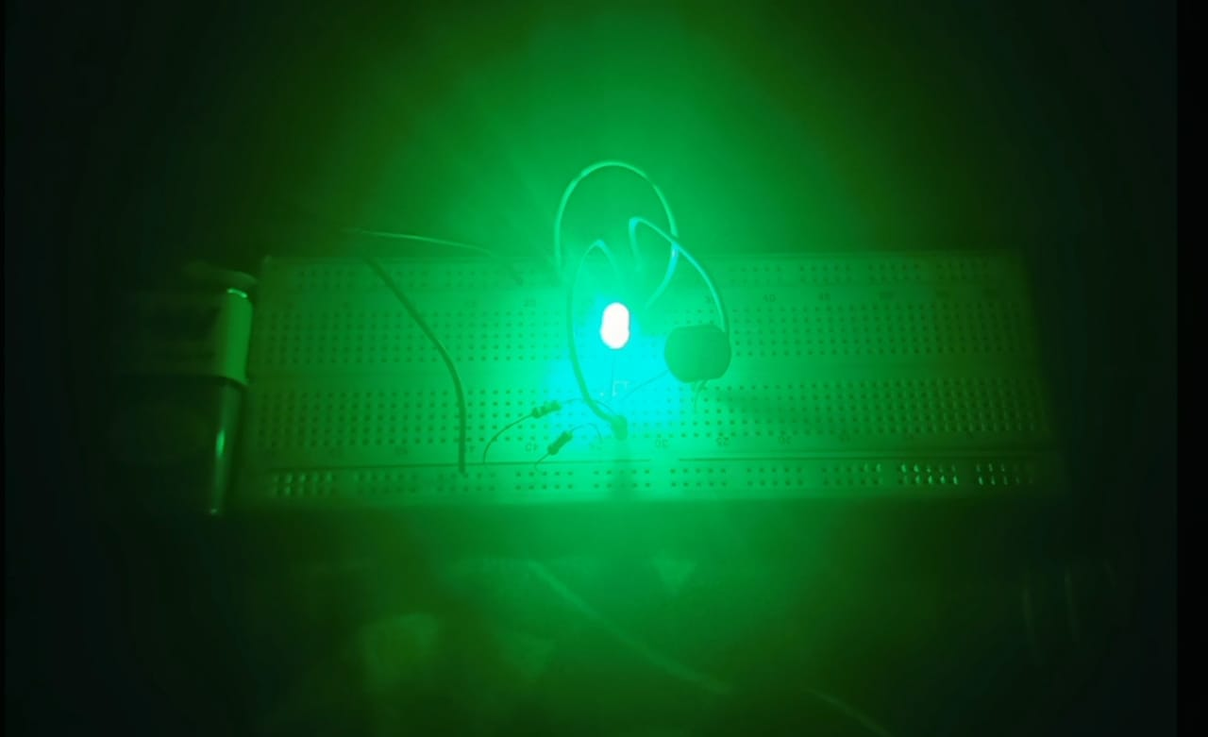 **During *night time***

**ADVANTAGES**

* Energy savings
* Low cost
* Safety and Security
* Automated operation
* Very flexible
* Easy to manufactured in sunny and rainy days, on and off time differ notice which is one of the major disadvantages of using timer circuit or manual operation for switching the street light system.

**APPLICATIONS**

* Street lights
* Vehicle head lamps
* Lights in the remote locations
* Camera shutter control
* Domestic lights

**CONCLUSION**

More effective in case of cost, man power and security as compare with today's running complicated and complex light controlling systems. Automatic Light Controlling System puts up a very user friendly approach and could increase the power. This the light controller using LDR based Light intensity. Circuit works properly to turn street lamp ON/OFF. LDR sensor and the solar panel (electrical energy) are the two main conditions in working the circuit. If the two conditions have been satisfied the circuit will do the desired work according to specific program. LDR sensor controls the turning ON or OFF the lighting column. This solar based automatic ON/OFF of the light does not require any transmission lines ,manual work for the switch on the lights in the night time and switching of the lights in the morning time.